Silhouette metric for img015001.jpg is: 0.7460060779429278

Davies Bouldin metric for img015001.jpg is: 0.28325842728134465

Calinski Harabasz metric for img015001.jpg is: 248799.98276625827

ID 0: (1750, 676)

ID 1: (135, 607)

ID 2: (1542, 653)

ID 3: (58, 720)

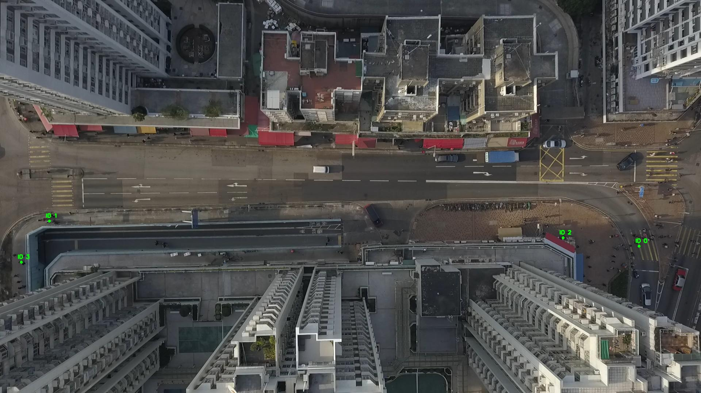

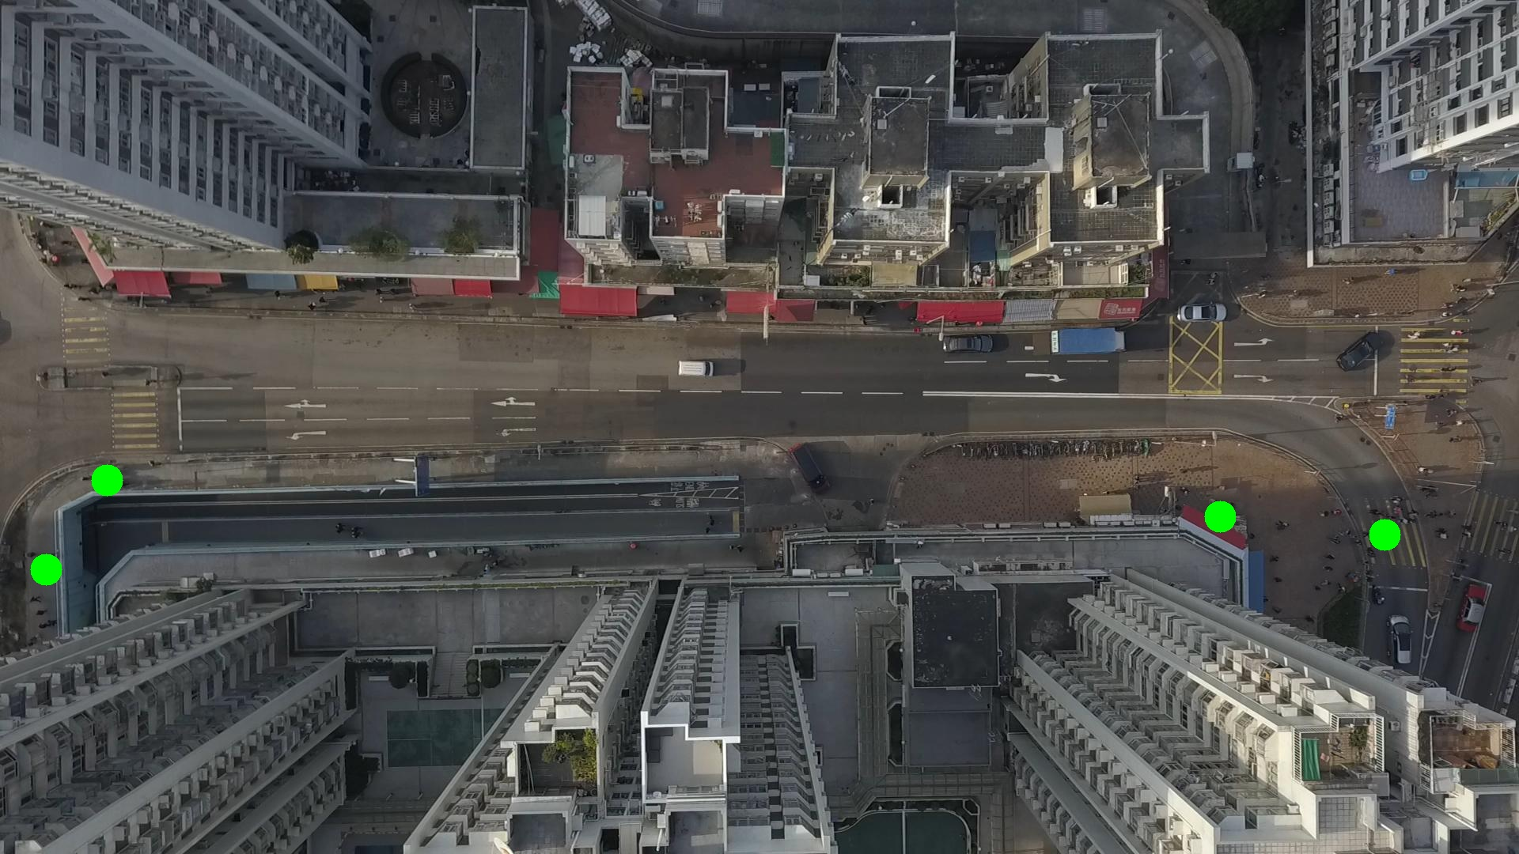

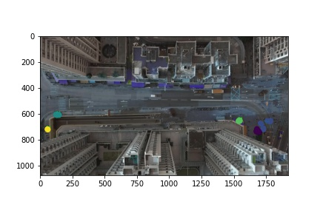

Silhouette metric for img015002.jpg is: 0.7895611862413207

Davies Bouldin metric for img015002.jpg is: 0.18681284535524867

Calinski Harabasz metric for img015002.jpg is: 380453.97907923505

ID 0: (1749, 659)

ID 1: (133, 607)

ID 2: (1542, 653)

ID 3: (44, 758)

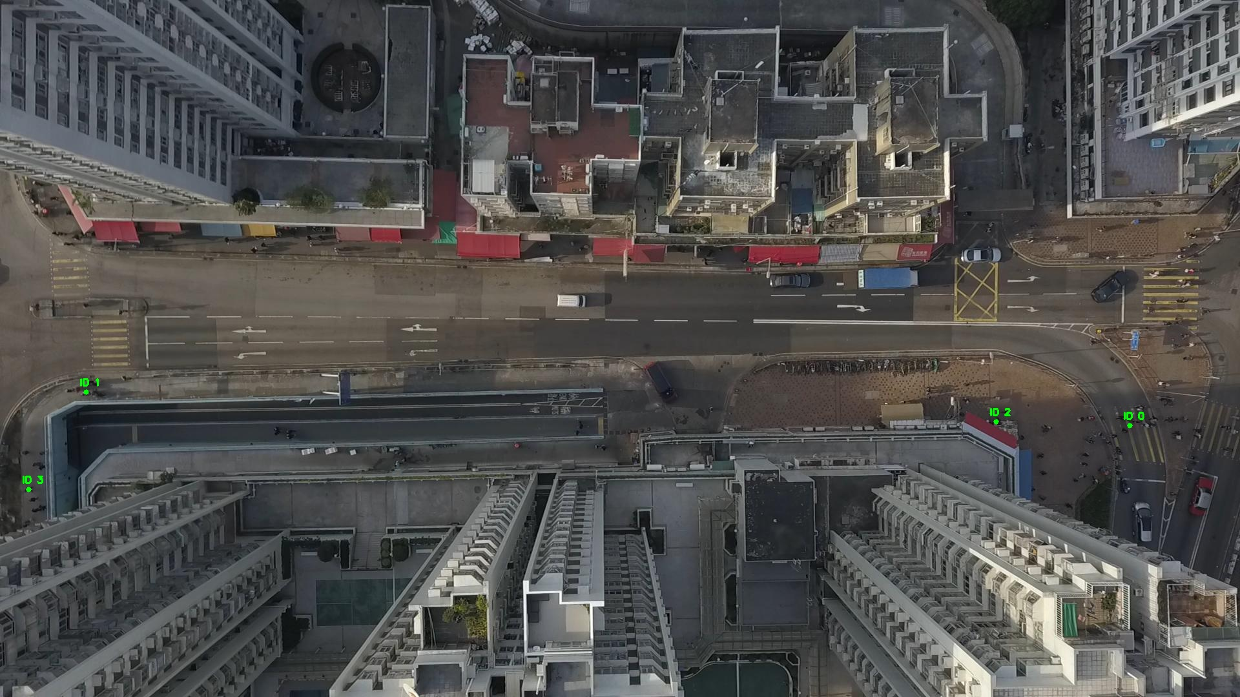

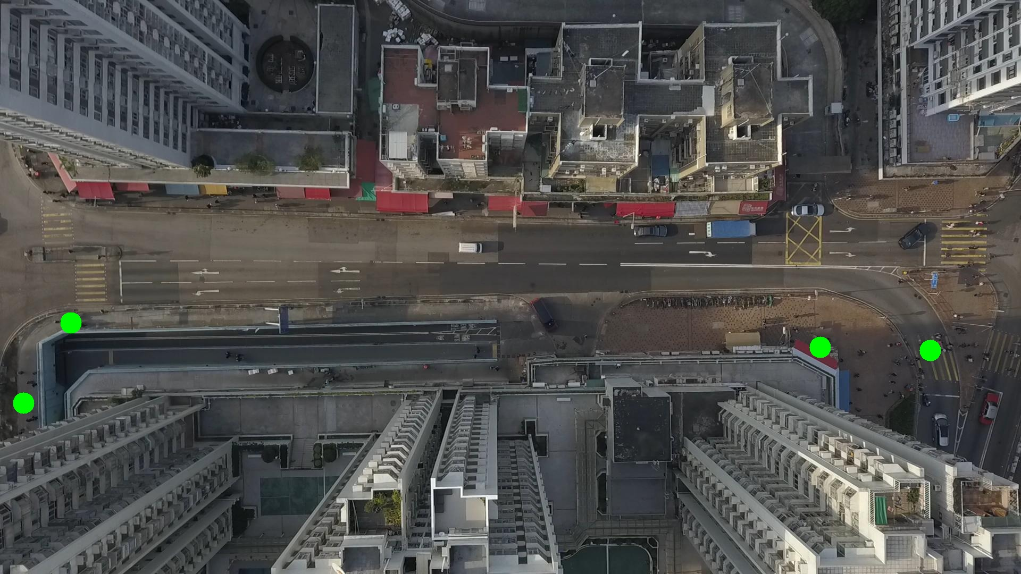

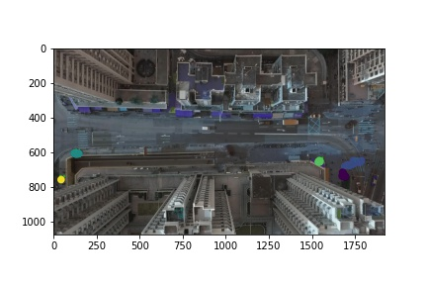

Silhouette metric for img015003.jpg is: 0.7691320329211171

Davies Bouldin metric for img015003.jpg is: 0.25928283919449824

Calinski Harabasz metric for img015003.jpg is: 331393.46350921027

ID 0: (1747, 661)

ID 1: (133, 607)

ID 2: (1541, 653)

ID 3: (53, 734)

ID 4: (1692, 713)

ID 5: (333, 1053)

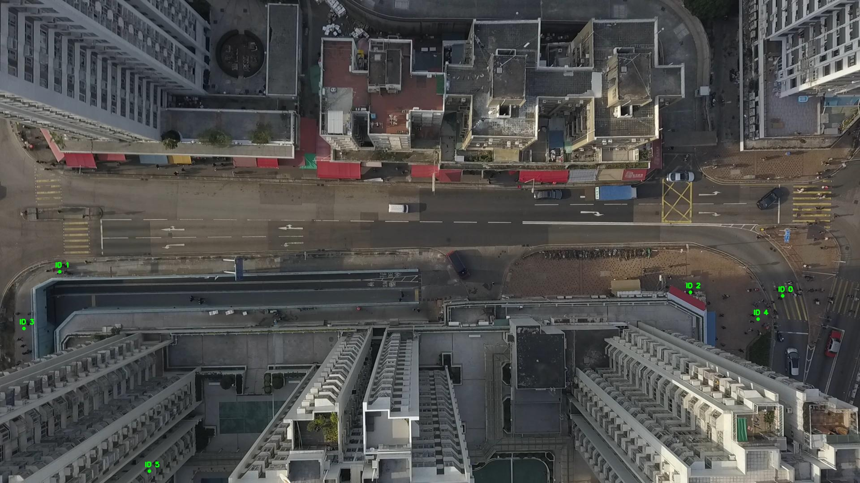

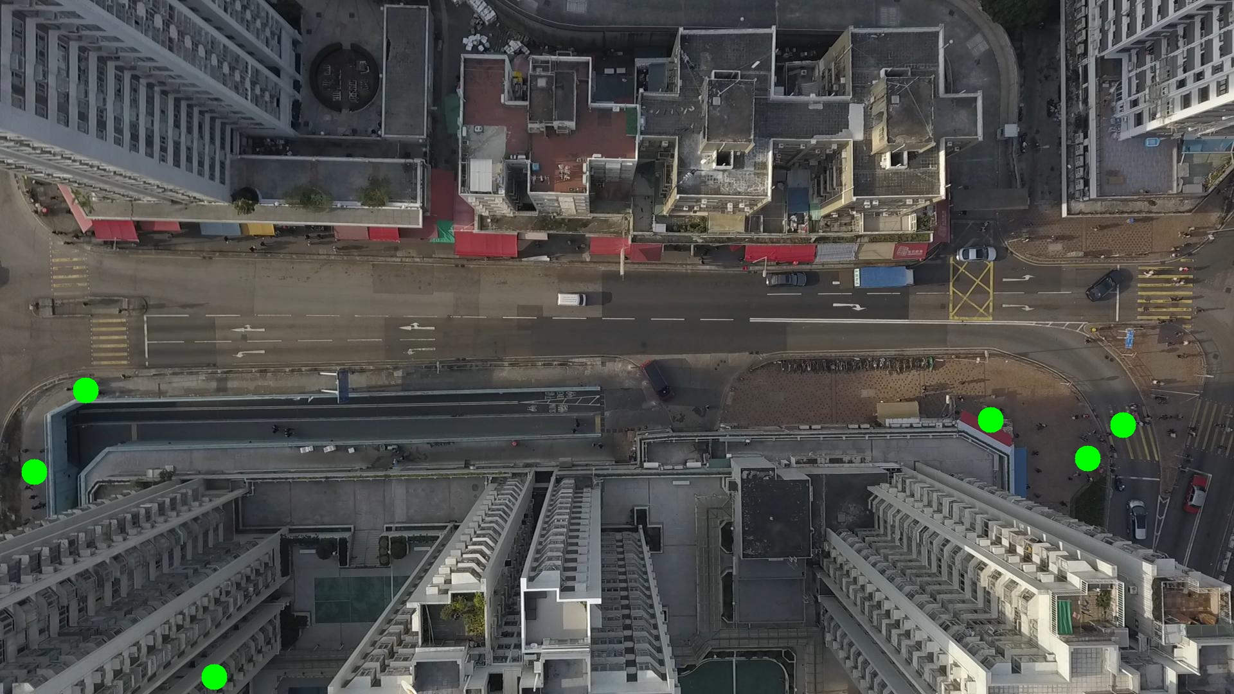

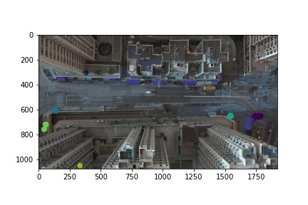

Silhouette metric for img015004.jpg is: 0.8612861372363416

Davies Bouldin metric for img015004.jpg is: 0.2050617389330442

Calinski Harabasz metric for img015004.jpg is: 549675.1204775438

ID 0: (1754, 658)

ID 1: (132, 607)

ID 2: (1543, 653)

ID 3: (55, 723)

ID 4: (1695, 722)

ID 5: (333, 1053)

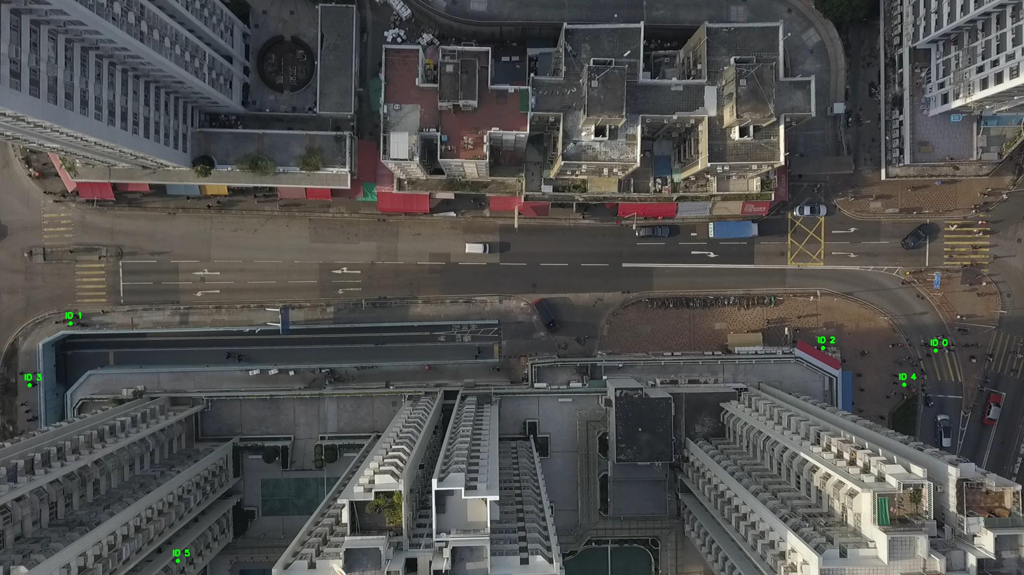

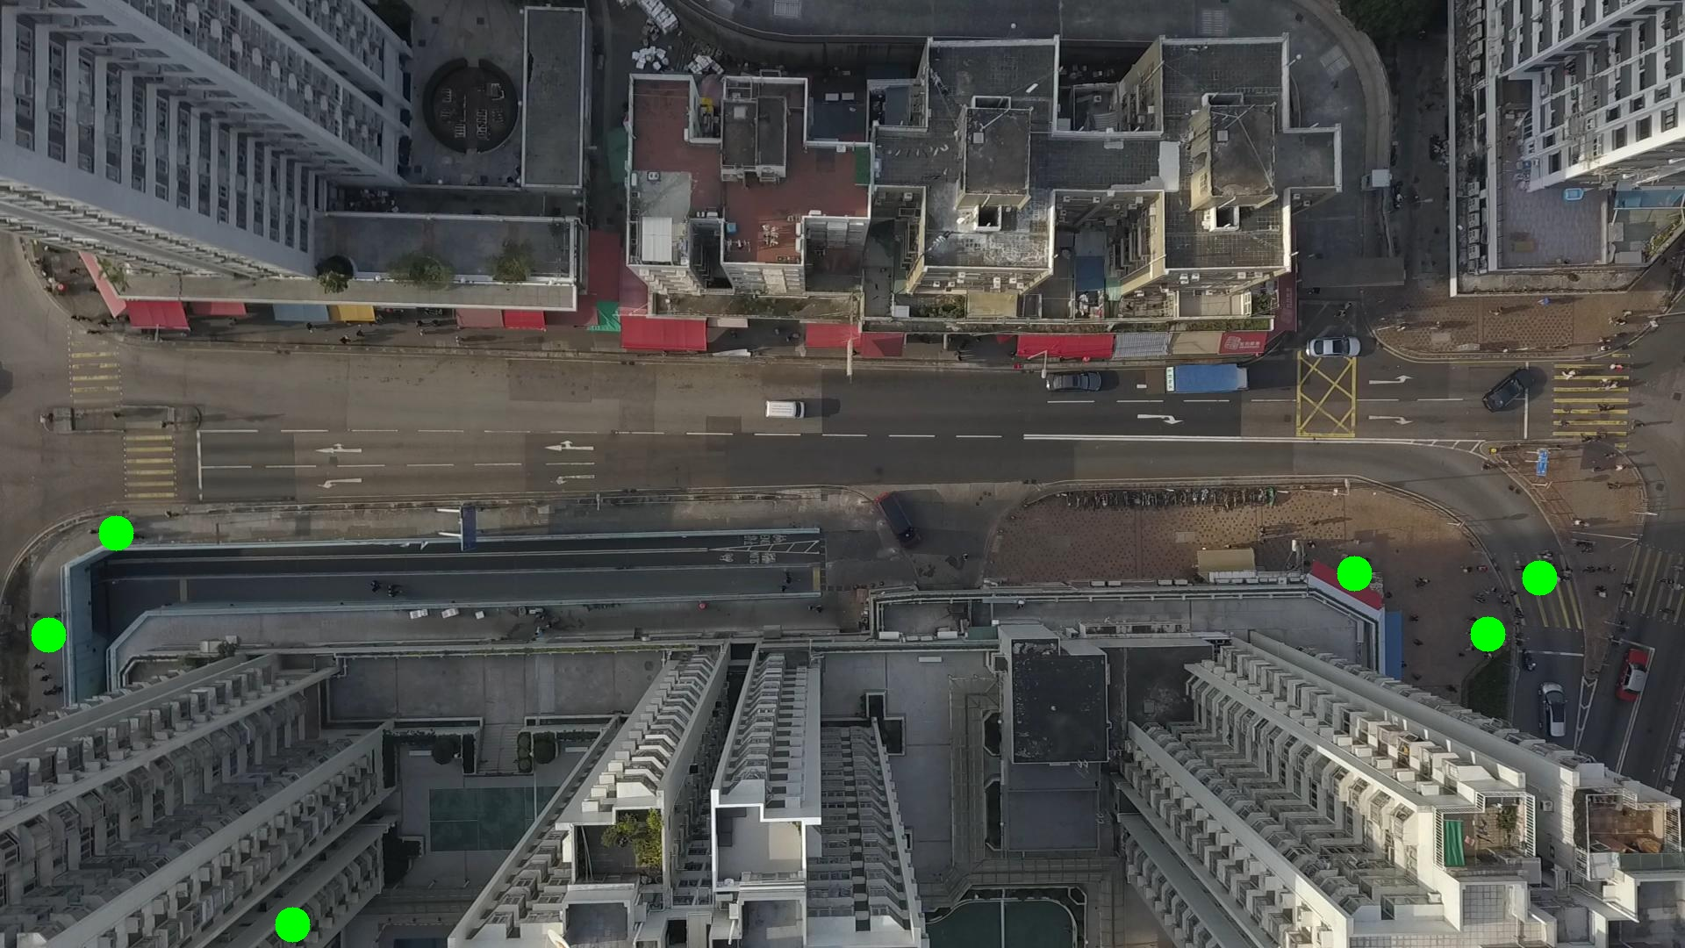

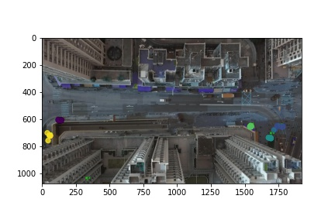

Silhouette metric for img015005.jpg is: 0.7900634496039796

Davies Bouldin metric for img015005.jpg is: 0.3442534082113561

Calinski Harabasz metric for img015005.jpg is: 252103.4767635257

ID 0: (1754, 658)

ID 1: (132, 608)

ID 2: (1543, 653)

ID 3: (60, 722)

ID 4: (1700, 711)

ID 5: (333, 1053)

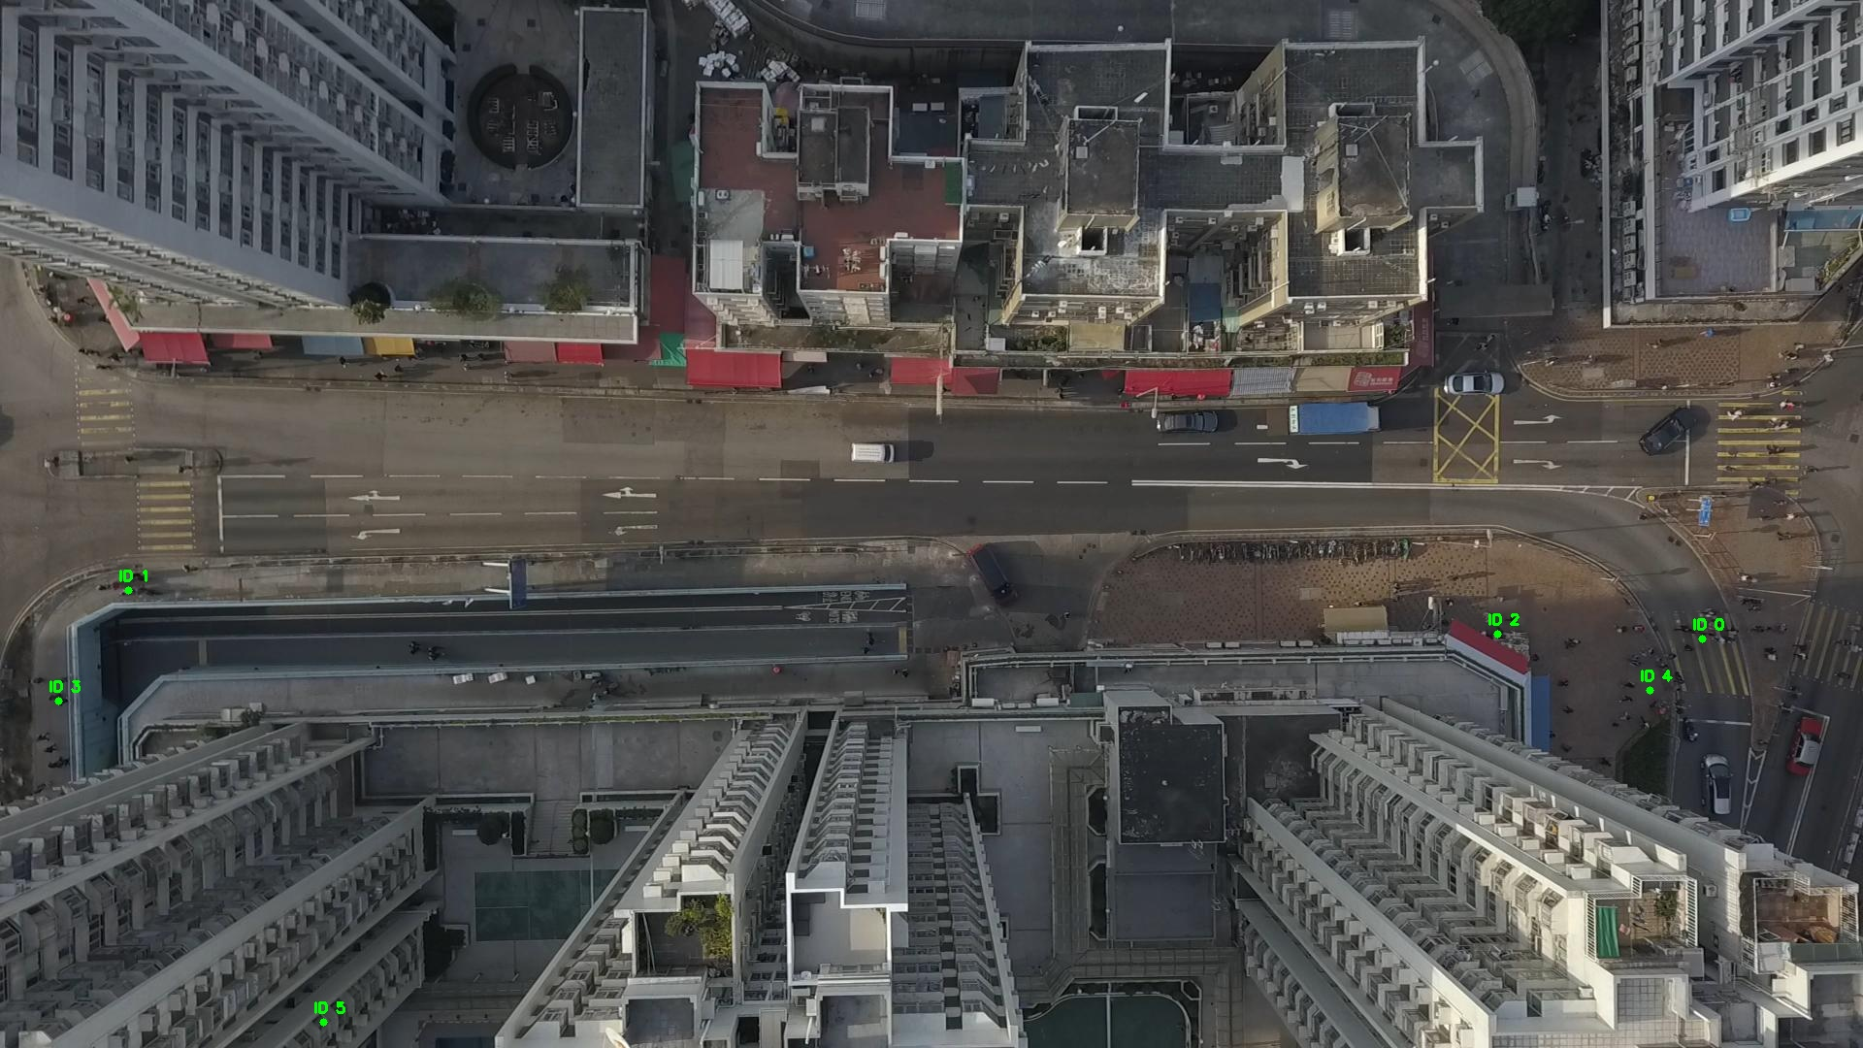

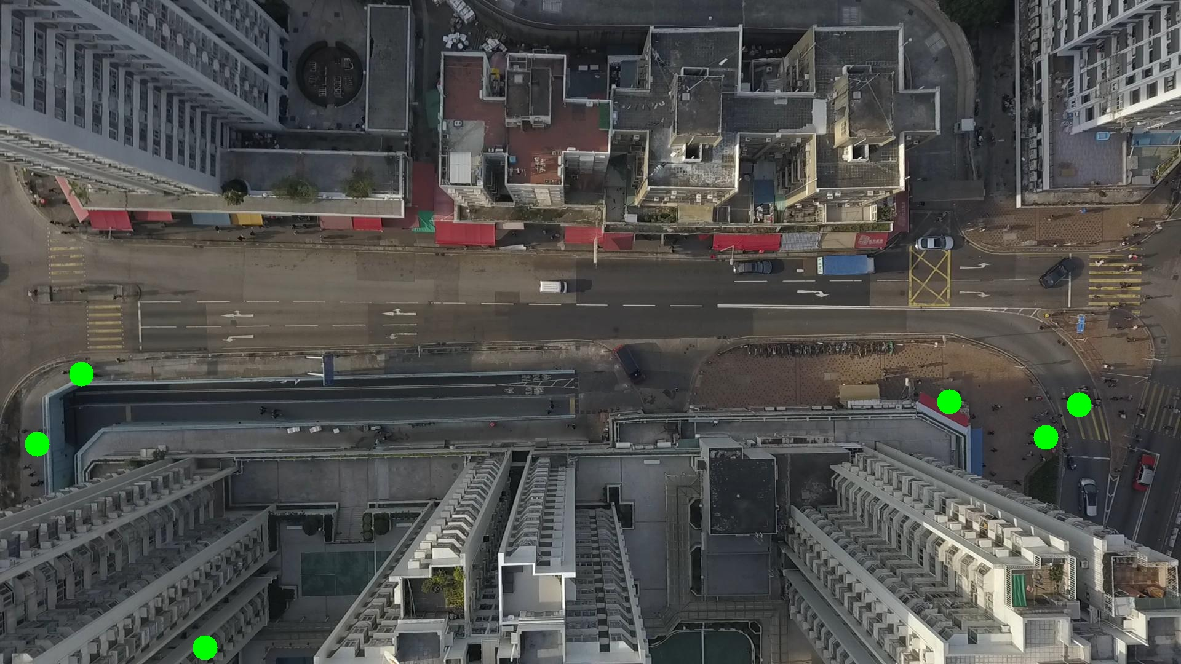

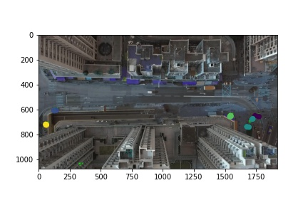

Silhouette metric for img015006.jpg is: 0.8693940791543762

Davies Bouldin metric for img015006.jpg is: 0.225644068080639

Calinski Harabasz metric for img015006.jpg is: 511390.8469174557

ID 0: (1764, 661)

ID 1: (132, 608)

ID 2: (1543, 653)

ID 3: (61, 721)

ID 4: (1700, 715)

ID 5: (333, 1053)

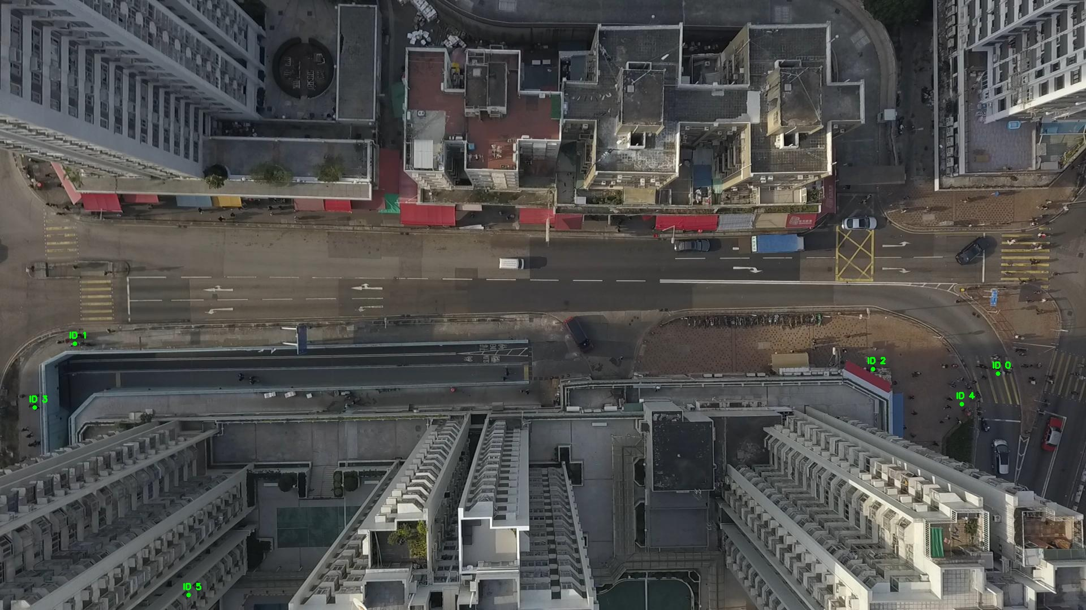

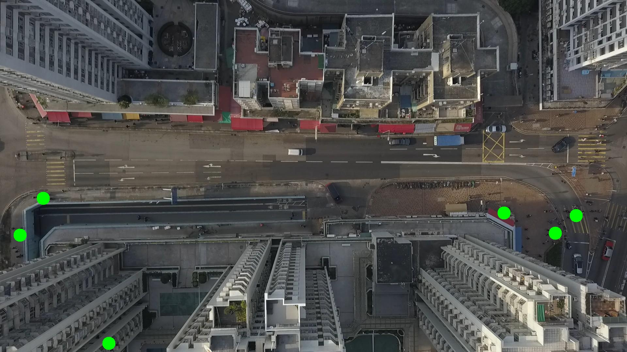

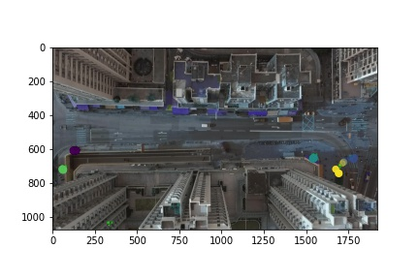

Silhouette metric for img015007.jpg is: 0.9146035209563687

Davies Bouldin metric for img015007.jpg is: 0.16794886675521367

Calinski Harabasz metric for img015007.jpg is: 638046.582577544

ID 0: (1764, 661)

ID 1: (131, 608)

ID 2: (1542, 653)

ID 3: (61, 721)

ID 4: (1697, 693)

ID 5: (333, 1053)

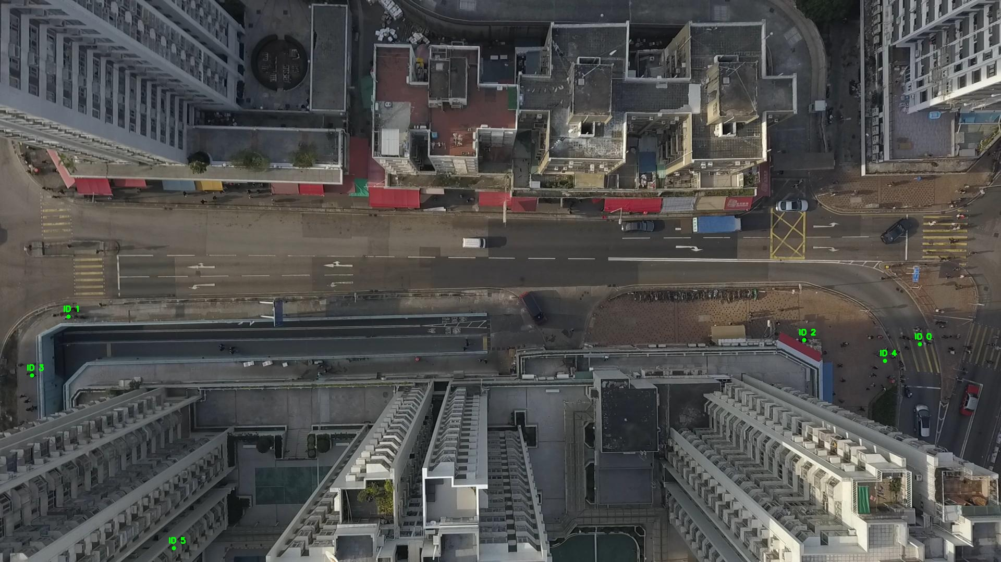

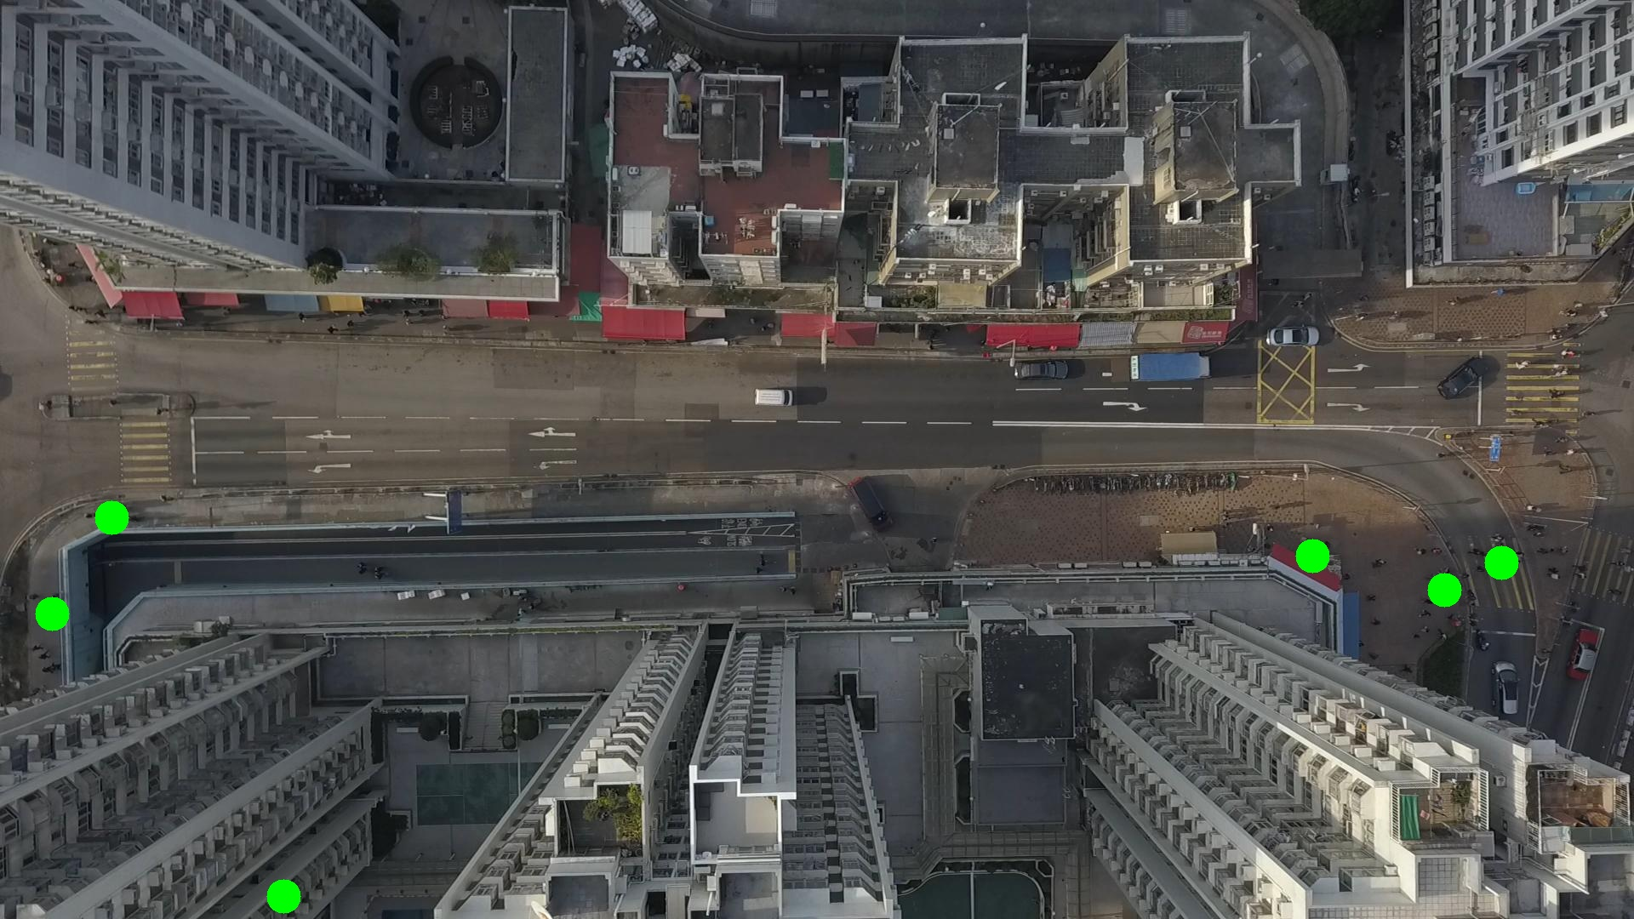

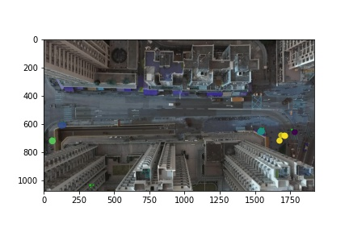

Silhouette metric for img015008.jpg is: 0.8236482620251558

Davies Bouldin metric for img015008.jpg is: 0.29369031353285163

Calinski Harabasz metric for img015008.jpg is: 346346.9455986722

ID 0: (1730, 666)

ID 1: (133, 608)

ID 2: (1543, 653)

ID 3: (59, 719)

ID 4: (1697, 693)

ID 5: (333, 1053)

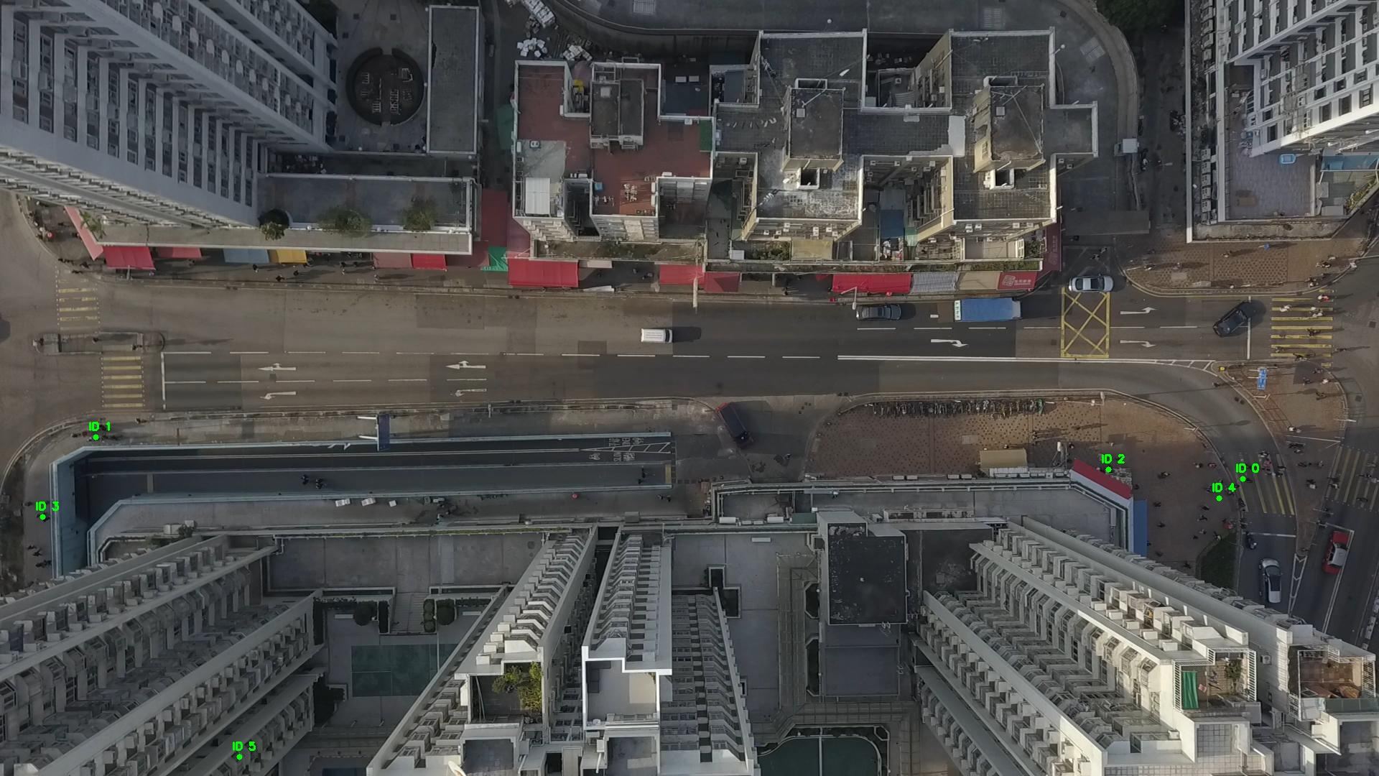

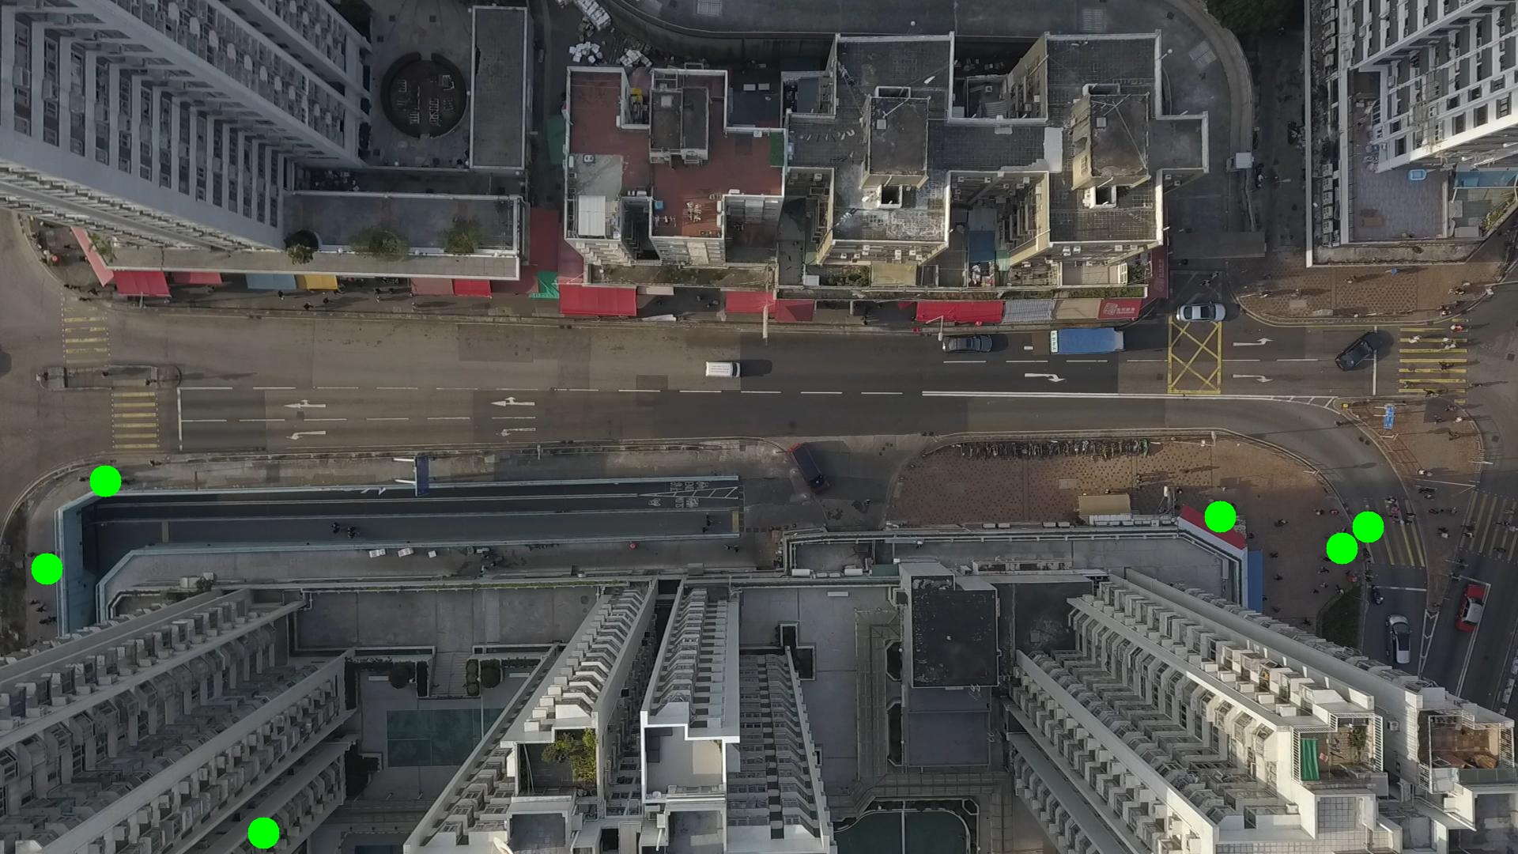

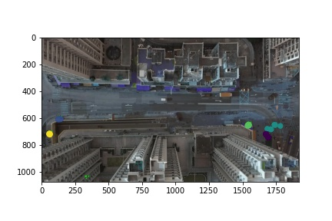

Silhouette metric for img015009.jpg is: 0.7935720488691542

Davies Bouldin metric for img015009.jpg is: 0.2804878882673331

Calinski Harabasz metric for img015009.jpg is: 110758.77669552913

ID 0: (1757, 654)

ID 1: (137, 609)

ID 2: (1543, 653)

ID 3: (61, 718)

ID 4: (1697, 693)

ID 5: (333, 1053)

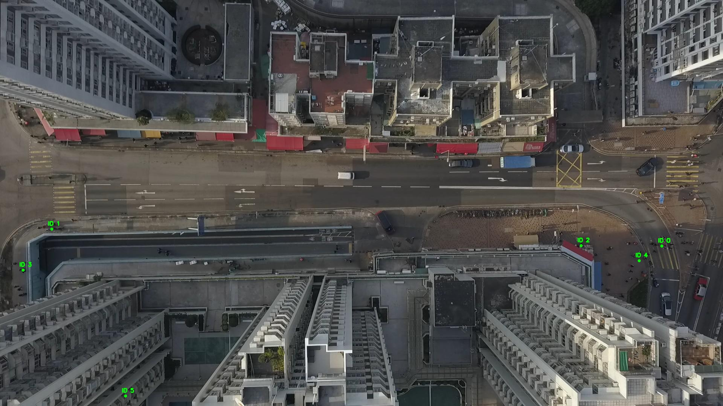

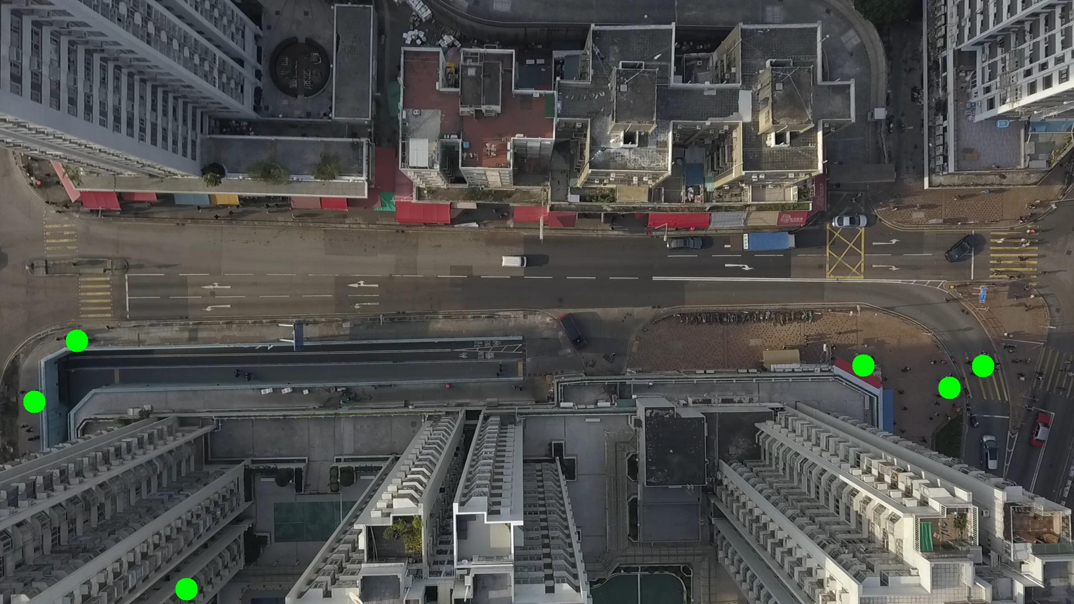

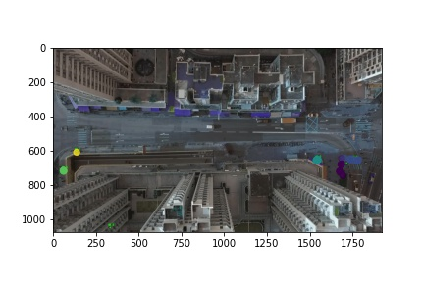

Silhouette metric for img015010.jpg is: 0.8865614311219027

Davies Bouldin metric for img015010.jpg is: 0.11146627735594436

Calinski Harabasz metric for img015010.jpg is: 312879.75632520264

ID 0: (1764, 655)

ID 1: (139, 608)

ID 2: (1543, 653)

ID 3: (51, 758)

ID 4: (1673, 721)

ID 5: (333, 1053)

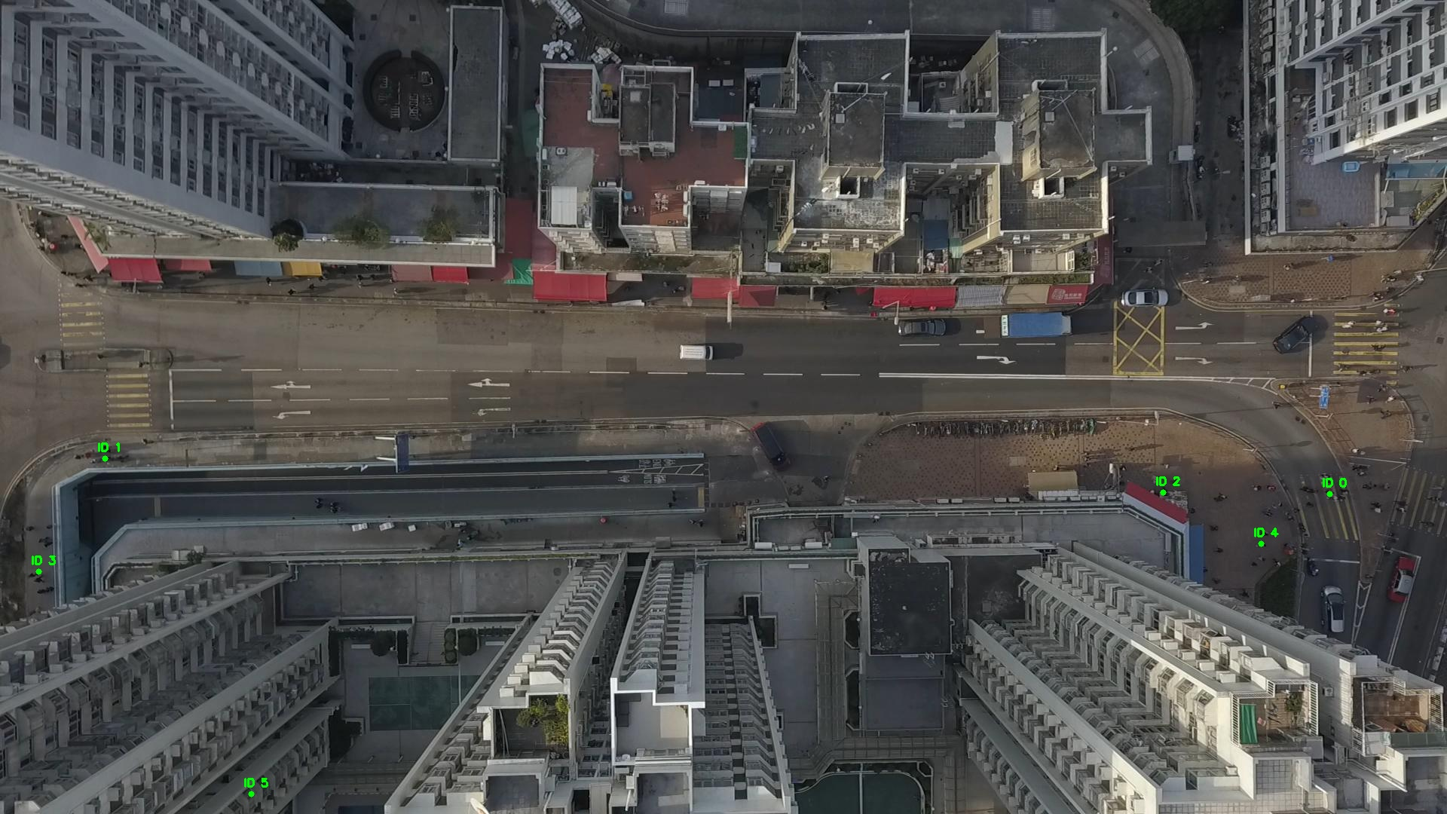

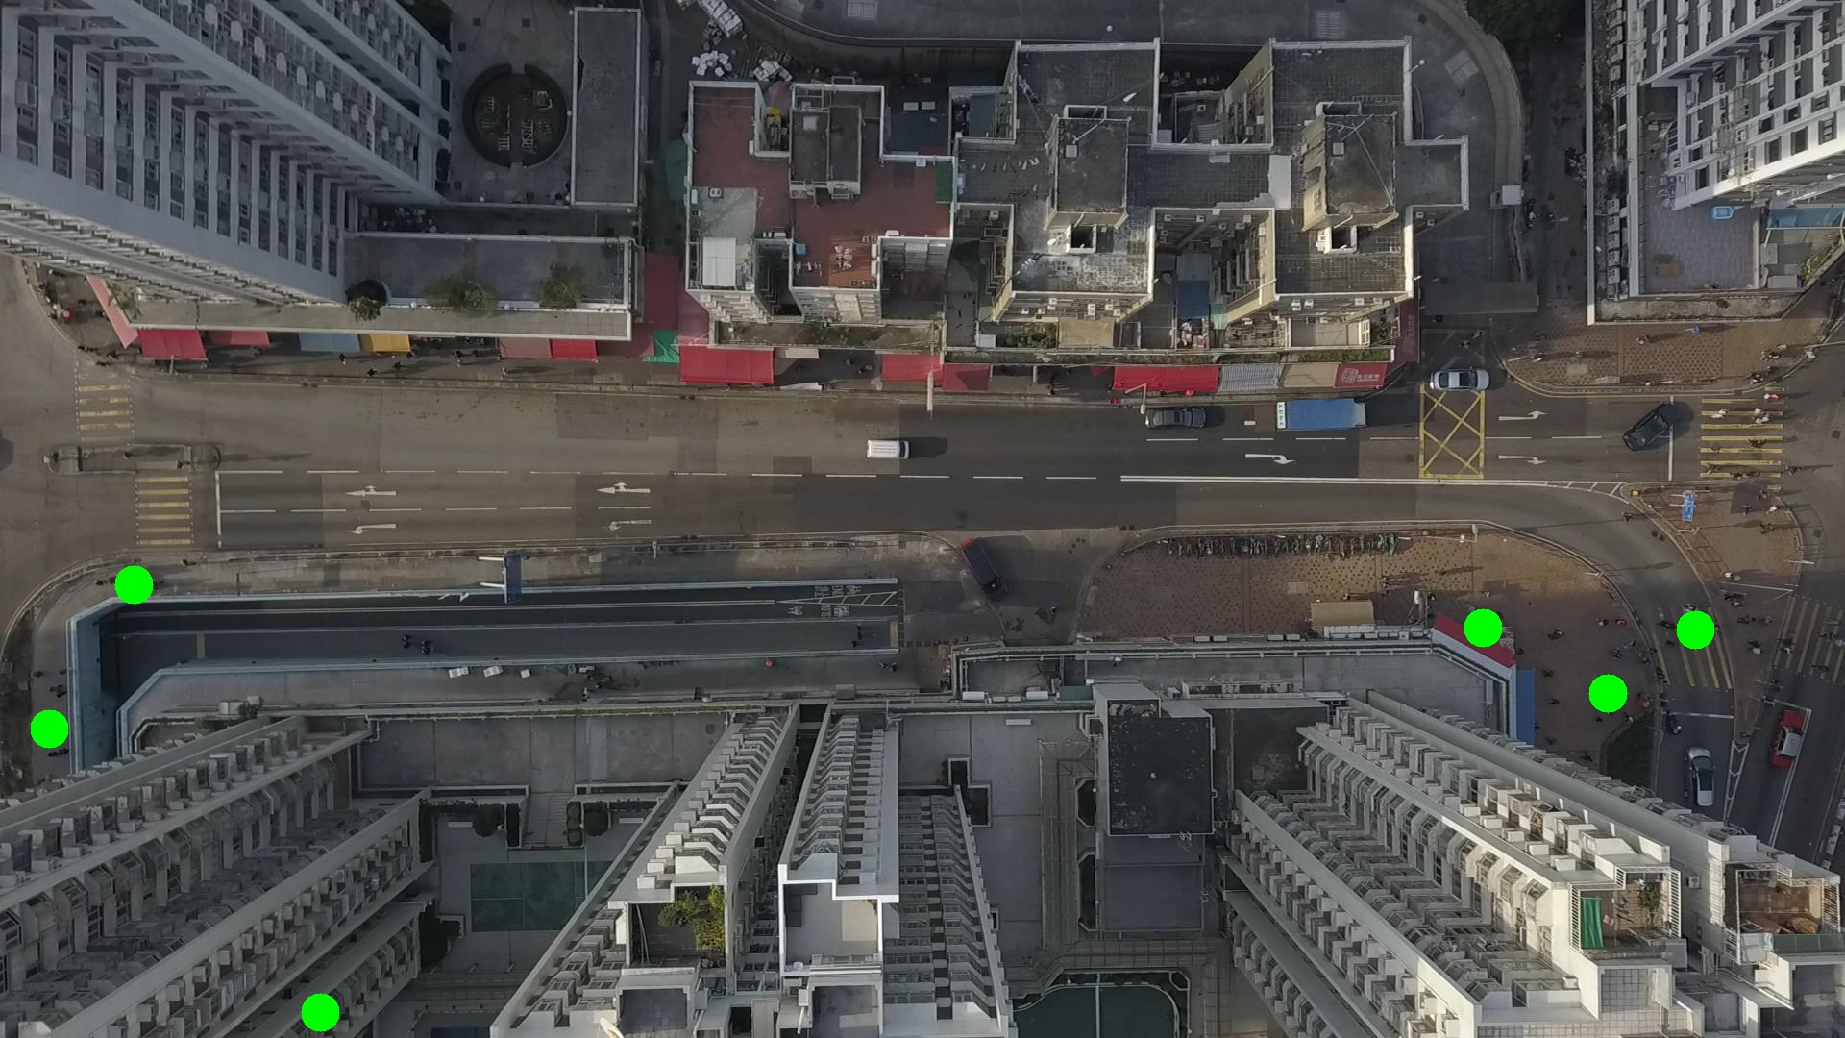

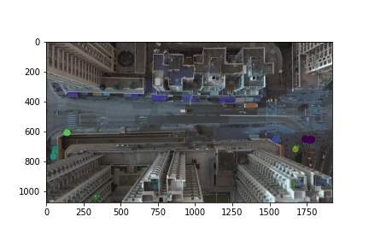

Silhouette metric for img015011.jpg is: 0.9342762978800044

Davies Bouldin metric for img015011.jpg is: 0.20231429544932023

Calinski Harabasz metric for img015011.jpg is: 775608.1214190148

ID 0: (1773, 656)

ID 1: (139, 608)

ID 2: (1543, 653)

ID 3: (48, 768)

ID 4: (1678, 704)

ID 5: (333, 1053)

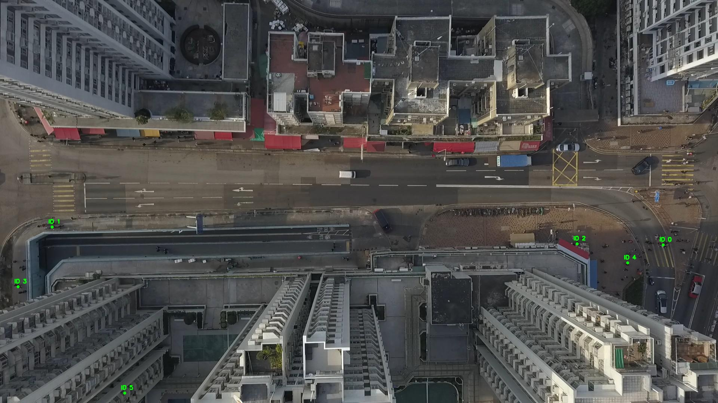

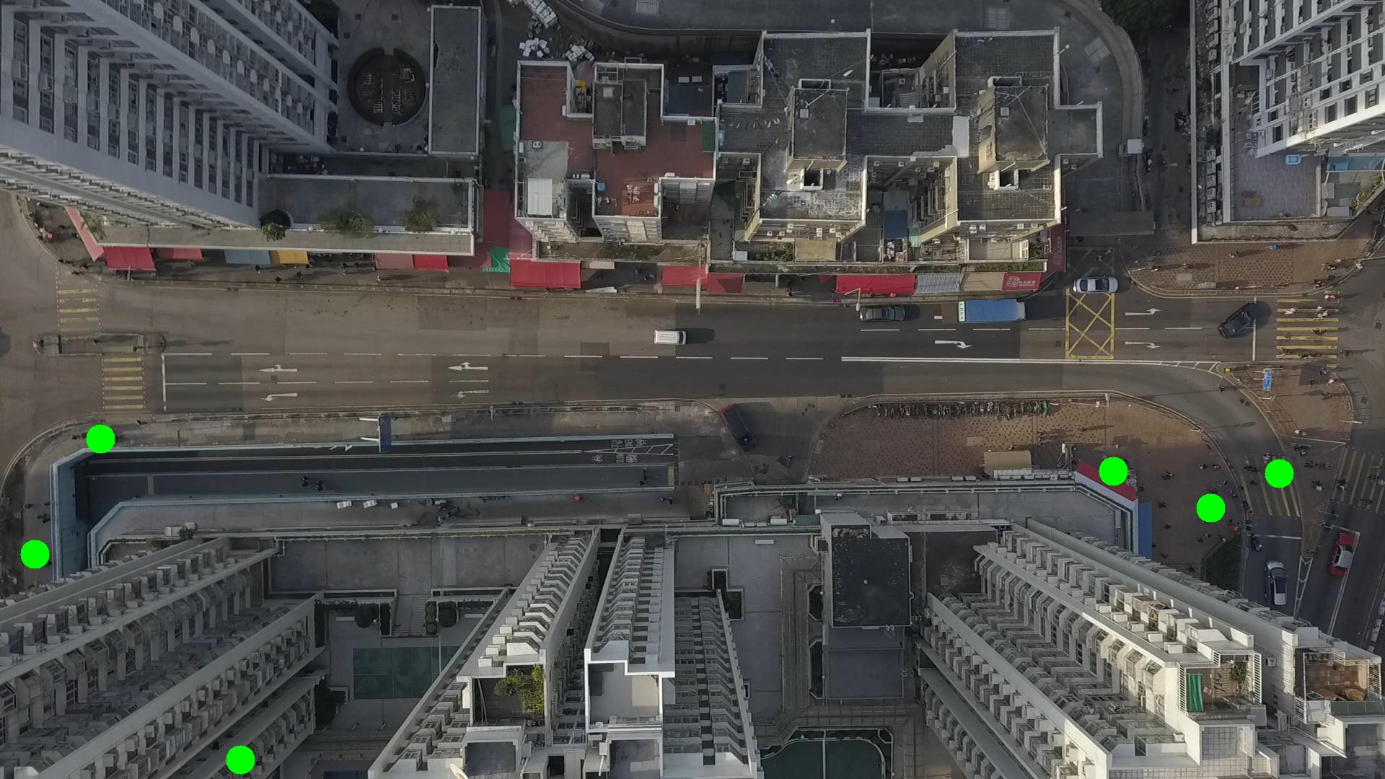

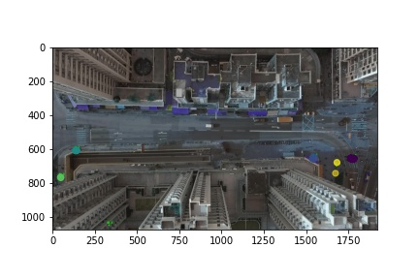

Silhouette metric for img015012.jpg is: 0.9654552112547155

Davies Bouldin metric for img015012.jpg is: 0.069721379676171

Calinski Harabasz metric for img015012.jpg is: 1538789.2623198582

ID 0: (1780, 656)

ID 1: (138, 608)

ID 2: (1543, 653)

ID 3: (48, 768)

ID 4: (1682, 674)

ID 5: (333, 1053)

